Religious Instruction
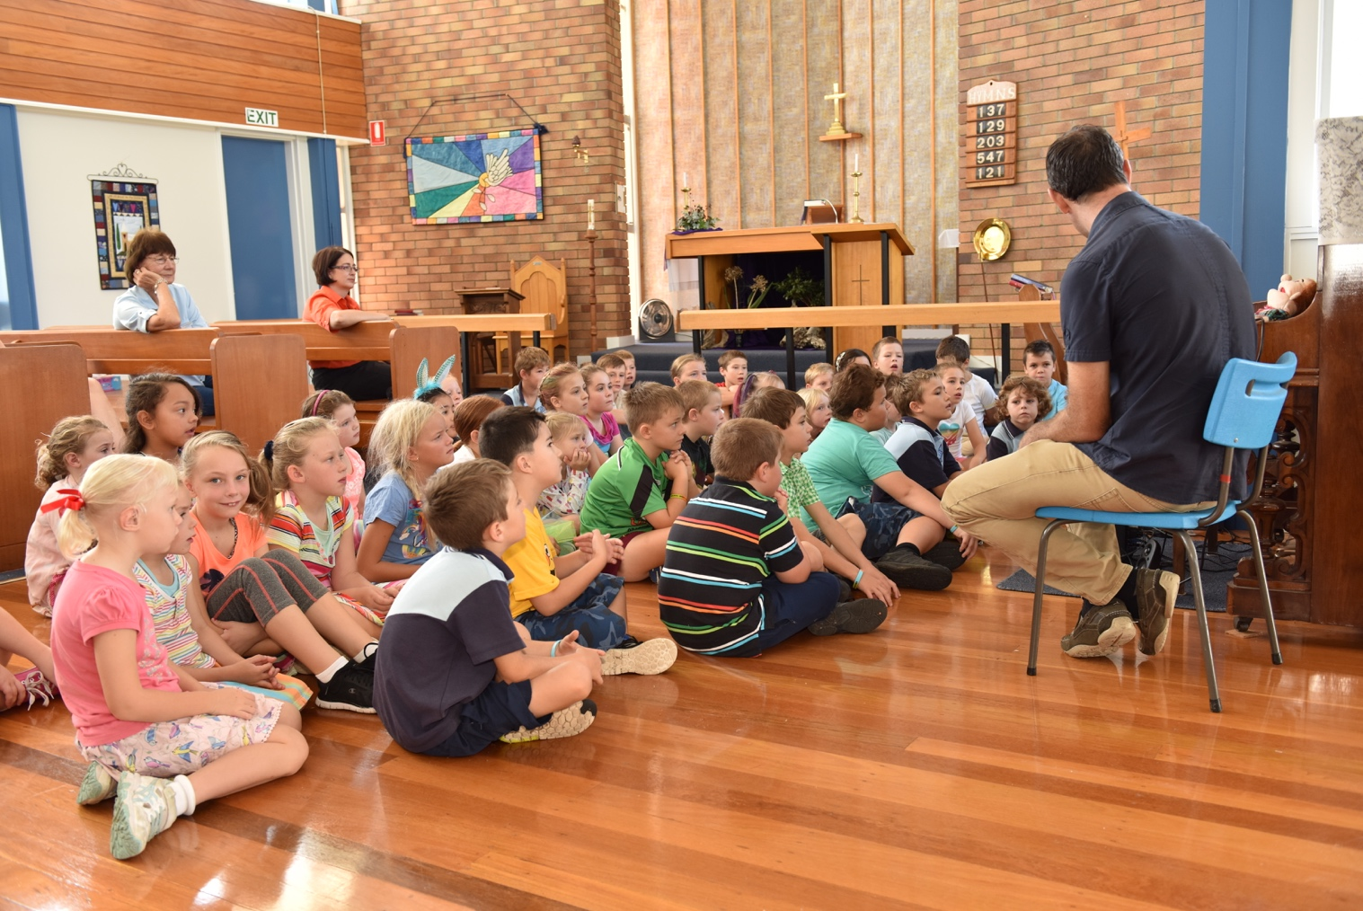
Killarney P-10 State School offers non-denomination cooperative religious instruction with community members visiting Years 1 – 6 classrooms weekly to instruct classes in matters religious. The cooperative classes cater for the following faiths: Anglican, Roman Catholic, Uniting, Warwick Christian Fellowship and Restoration and Revival Ministries. Non-members of these faiths are still permitted to attend. Attendance is allocated on the basis of details provided at time of enrolment or otherwise notified in writing.
Killarney P-10 State School embraces a multitude of cultural, religious and non-religious beliefs and encourages students to grow and develop as a whole person, in particular, in beliefs, values and attitudes and is based on the Access Ministries authorized program. Killarney P-10 State School respects the background and beliefs of all students by not promoting, or being perceived as promoting, any particular set of beliefs in preference to another.
Religious instruction is not a program or syllabus provided by Education Queensland.
Students who are not participating in RI will be provided with other instruction in a separate supervised location. Other instruction must relate to part of a subject area already covered in class and may include, but is not restricted to:
- personal research and/or assignments
- revision of class work such as creative writing or literacy and/or numeracy activities which could include online programs currently accessed by the students
- wider reading such as independent reading appropriate to the student

