Year 9/10
Book List
2026
BOOKS |  |  |  | 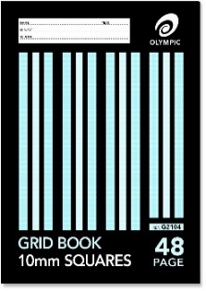    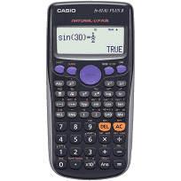  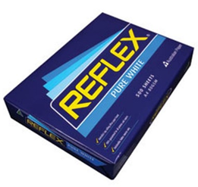
 |  | 5 | 64 page Blue Lined A4 Exercise Books NO multi-subject books
 |  | 1 | 48 page A4 5mm Grid Book
 |  | 1 | 64 page Blue Lined A4 Exercise book
 |  |  | CONSUMABLES (Voluntary)
 |  | 2 | A4 Reams of Reflex paper (80 gsm – photocopier manufacturer recommended)
 |  | 2 | Large Boxes of Tissues
 |  |  | STATIONERY
 |  | 1 | Pencil Case
 |  | 7 | Plastic Document Wallets – Foolscap (1 per subject)
 |  | 4 | Staedtler / quality Pencils – 2 x HB and 2 x 2B
 |  | 4 | Pens – 2 x red, 4 x blue / black NO multi-coloured / gel pens
 |  | 1 | Sharpener
 |  | 2 | White Eraser (no novelty erasers)
 |  | 1 | Colouring Pencils (box of 12)
 |  | 1 | Coloured Felt Pens (packet of 12)
 |  | 1 | Clear Hard Plastic or Wooden Ruler (must have millimetres and centimetres marked on it)
 |  | 1 | Scissors (sharp)
 |  | 4 | Bostik GluStiks (35 g)
 |  | 4 | Highlighters (pink, blue, green, yellow)
 |  | 2 | USB Memory Sticks – minimum 64GB each
 |  | 1 | Calculator – Scientific Casio FX-82au
 |  | 1 | Compass Set & 180 Degree Protractor
 |  | 1 | Laptop Mouse (optional)
 |  | 1 | Headphones
Request for particular brands is due to quality which avoids constant replacement.

- Please clearly mark ALL belongings with your child’s name, including clothing.
- For protection and easier recognition, please cover your child’s books with a plastic slip cover or contact.
- Please mark your child’s NAME on the name label on the front cover of the book.
- Please leave the subject name off on any exercise book or scrapbook.
- Years 1-6 will be provided with a free Primary Planner (diary).
- Please note some consumables e.g. glue, pencils may need to be replaced throughout the year.

