Year 7/8
Book List
2026
BOOKS |  |  | 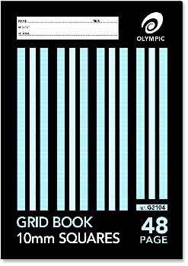  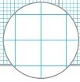  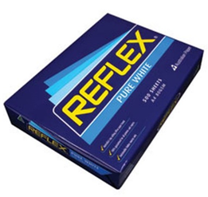  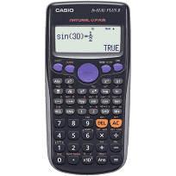
 | 6 | 64 page Blue Lined A4 Exercise Books NO multi-subject books
 | 1 | 48 page A4 10mm Grid Books (Japanese)
 | 1 | 48 page A4 5mm Grid Book (Maths)
 | 1 | A4 Lined Jotter Pad
 | 1 | Visual Arts Diary (new enrolments only)
CONSUMABLES (Voluntary)
 | 2 | A4 Reams of Reflex paper (80 gsm – photocopier manufacturer recommended)
 | 2 | Large Boxes of Tissues
STATIONERY
 | 1 | Pencil Case
 | 11 | Plastic Document Wallets – Foolscap (1 per subject)
 | 4 | Staedtler / quality Pencils – 2 x HB and 2 x 2B
 | 4 | Pens – 2 x red, 2 x blue / black NO multi-coloured / gel pens
 | 1 | Sharpener
 | 1 | White Eraser (no novelty erasers)
 | 1 | Colouring Pencils (box of 12)
 | 1 | Coloured Felt Pens (packet of 12)
 | 1 | Clear Hard Plastic or Wooden Ruler (must have millimetres and centimetres marked on it)
 | 1 | Scissors (sharp)
 | 2 | Bostik GluStiks (35 g)
 | 4 | Highlighters (pink, blue, green, yellow)
 | 2 | USB Memory Sticks – minimum 64GB each
 | 1 | Calculator – Scientific Casio FX-82au
 | 1 | Compass Set & 180 Degree Protractor
 | 1 | Laptop Mouse (optional)
 | 1 | Headphones
Request for particular brands is due to quality which avoids constant replacement.

- Please clearly mark ALL belongings with your child’s name, including clothing.
- For protection and easier recognition, please cover your child’s books with a plastic slip cover or contact.
- Please mark your child’s NAME on the name label on the front cover of the book.
- Please leave the subject name off on any exercise book or scrapbook.
- Years 1-6 will be provided with a free Primary Planner (diary).
- Please note some consumables e.g. glue, pencils may need to be replaced throughout the year.

