Year 6
Book List
2026
BOOKS |  |  | 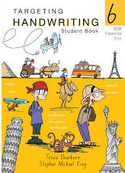  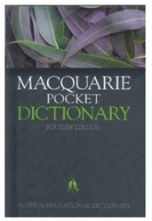  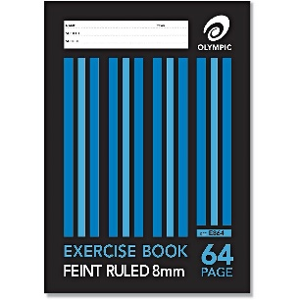  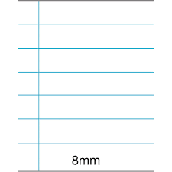  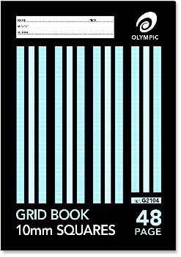  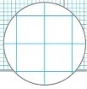  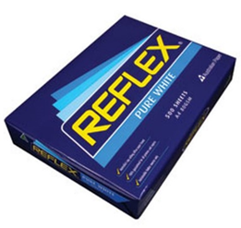
 | 1 | Macquarie Pocket Dictionary (purchased for Year 3)
 | 1 | Queensland Year 6 Targeting Handwriting Student Book
 | 12 | 96 page Blue Lined A4 Exercise Books
 | 2 | 48 page A4 10mm Grid Books
 | 1 | 96 page Scrapbooks
 | 1 | 96 page Scrapbook for Arts (new enrolments only)
 | 1 | Visual Arts Diary (new enrolments only)
 | 2 | A4 Display Folders
 |  | CONSUMABLES (Voluntary)
 | 2 | A4 Reams of Reflex paper (80 gsm – photocopier manufacturer recommended)
 | 2 | Large Boxes of Tissues
 |  | STATIONERY
 | 1 | Pencil Case (suitable for homework bag and desk)
 | 3 | Plastic Wallets – foolscap
 | 12 | Staedtler / quality HB Pencils
 | 1 | Artline 200, 0.4 fine tip black pen
 | 3 | Pens – 1 x red, 2 x blue NO multi-coloured / gel pens
 | 1 | Sharpener (metal)
 | 1 | Clear Hard Plastic or Wooden Ruler (must have millimetres and centimetres marked on it)
 | 3 | White Erasers (no novelty erasers)
 | 1 | Scissors (sharp)
 | 1 | Colouring Pencils (box of 12)
 | 1 | Coloured Felt Pens (packet of 10)
 | 4 | Highlighters (pink, blue, green, yellow)
 | 4 | Staedtler / Artline / Bic Thin Barrel Whiteboard Markers
 | 6 | Bostik GluStiks (35 g)
 | 1 | Non-Scientific calculator
Request for particular brands is due to quality which avoids constant replacement.
- Please clearly mark ALL belongings with your child’s name, including clothing.
- For protection and easier recognition, please cover your child’s books with a plastic slip cover or contact.
- Please mark your child’s NAME on the name label on the front cover of the book.
- Please leave the subject name off on any exercise book or scrapbook.
- Years 1-6 will be provided with a free Primary Planner (diary), Years 7-10 a Junior Secondary Planner.
- Please note some consumables e.g. glue, pencils may need to be replaced throughout the year.

