Prep
Book List
2026
BOOKS |  |  |   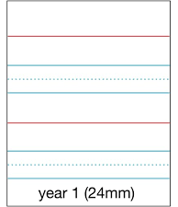  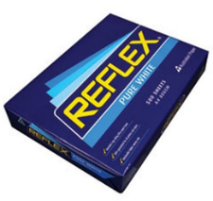  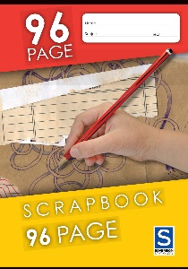  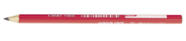
 | 2 | 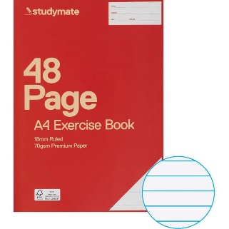  48 page A4 Blue Lined Exercise book
 | 5 | 96 page Scrapbooks
 | 1 | 96 page Scrapbook for Arts
 | 4 | A4 18mm Ruled Exercise Books
 | 1 | 48 page Year 1 Lined A4 Exercise Book
 | 1 | Visual Arts Diary
CONSUMABLES (Voluntary)
 | 2 | A4 Reams of Reflex paper (80 gsm – photocopier manufacturer recommended)
 | 2 | Large Boxes of Tissues
 |  | 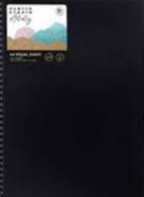
STATIONERY
 | 1 | Pencil Case (smaller size, suitable for desk tray)
 | 3 | Triangular Pencils
 | 2 | Staedtler / quality HB Pencils
 | 6 | Bostik GluStiks (35 g)
 | 6 | Artline / Bic / Staedtler Thin Barrel Whiteboard Markers (different colours)
 | 4 | White Erasers (no novelty erasers)
 | 1 | Scissors (rounded ends)
 | 1 | Library Bag – fabric
Request for particular brands is due to quality which avoids constant replacement.
- Please clearly mark ALL belongings with your child’s name, including clothing.
- For protection and easier recognition, please cover your child’s books with a plastic slip cover or contact.
- Please mark your child’s NAME on the name label on the front cover of the book.
- Please leave the subject name off on any exercise book or scrapbook.
- Years 1-6 will be provided with a free Primary Planner (diary).
- Please note some consumables e.g. glue, pencils may need to be replaced throughout the year.

